Cloud Computing – Session 5
Simple Storage Service (S3)

ASSIGNMENT - 1

SUBMITTED BY:
Mahendra M. Sunar

DATE: 13th July, 2017
Exploring Amazon Simple Storage Service (S3), Bucket is created, test file is uploaded and permission is set so that file can be viewed by everyone.
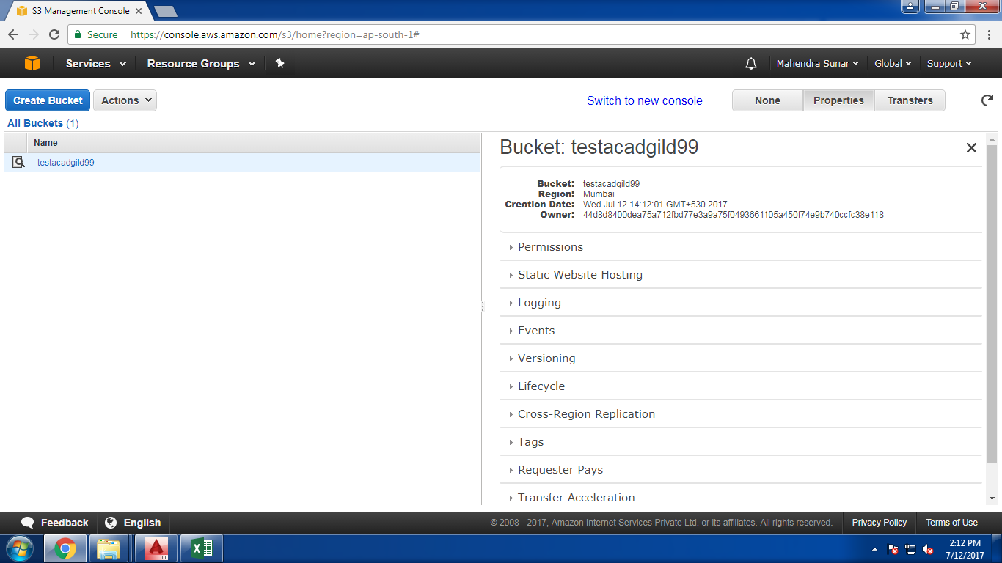
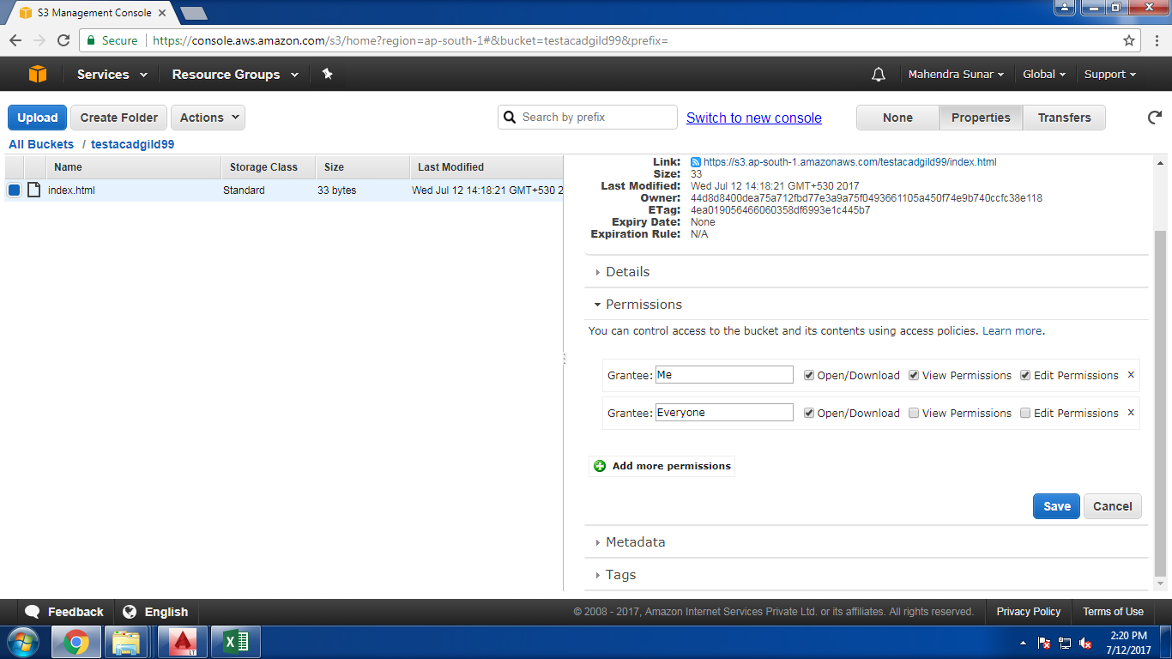

Bucket Policy is also generated
